**Profound Posterior Glenoid Deficiency: Case Discussion**

***9/5/2020***

***JP Warner***

Dear CSS Membership:  
  
Please consider this case of a young patient with a profound posterior glenoid deficiency. This is a problem we have considered in the past. I welcome your input and recommendations.  
  
Kind Regards,  
  
JP Warner, MD  
Founder, CSS

***9/5/2020***

***Bassem Elhassan***

Good morning JP

We have discussed similar cases in the past with the Codman group and it is always great to learn from everyone about this difficult problem.

For this young age, I have done fresh osteochondral glenoid allograft or Tibial Plafond, in addition to Botox injection to the subscapularis 1 week prior to surgery. If the biceps is symptomatic, I add subpectoral biceps tenodesis as well.

Probably I have done 9? of these I have to check.

There is one in particular who I recall very well, because he was a body builder champion of Kuwait two years in a row and had bilateral shoulder dysplasia like this one but much worse and symptomatic on the right side.

We did use Tibial plafond fresh allograft. I do have intraop video, tried to shorten it but still 90 Mb can’t send by email.

But I have attached his pre and post op CT scan

He is two years now from surgery and very happy. Not sure what is going to happen in the long term

B

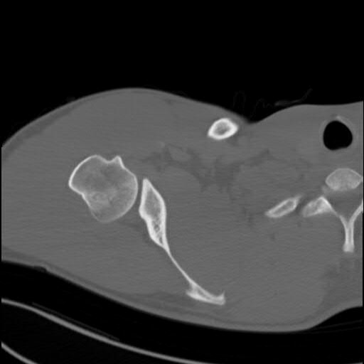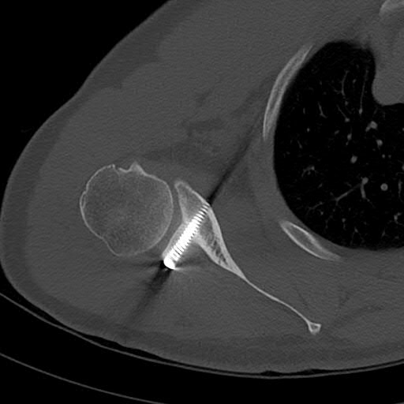

***9/5/2020***

***Stephen Parada***

Bassem,

Great case as always. I have a similar case where I tried to alter the neoglenoid surface by making it more angulated in an attempt to better center the humerus.

This surgery failed fairly miserably! (attached).

When I revised him to a less angulated bone block, he did great and immediately "felt" better.

What are your thoughts on altering the humeral station with regards to subluxation as well as your goal for the angle of the bone block and resulting alteration of the glenoid version during these difficult cases?

With less dysplastic cases, I have always just tried to replicate "normal" anatomy with a posterior glenoid reconstruction, but I think that's why the case I attached failed, because I clearly did not change the resting position of the humerus and it just aggressively wore his humeral head cartilage.

I appreciate your insight.

-Steve

***9/5/2020***

***Emilio Calvo***

Great cases Steve and Bassem.

We studied 30 patients with posterior shoulder instability all treated by me with arthroscopic posterior capsulolabral repair (submitted for publication). Results were satisfactory except for those 3 with posterior humeral subluxation and posterior glenoid cartilage erosion. These three patients continued with pain and sholder looseness in FF over 90 deg. Humeral head continued subluxated on CT scan spite good capsulolabral healing. Revision with posterior glenoid augmentation with bone block did not help and OA progressed rapidly in 2 of them. One of these 3 patients is developing similar symptoms and abnormalities in the opposite shoulder ...

In summary, posterior glenoid version, static post humeral head subluxation and post glenoid cartilage erosion seem to be poor prognostic factors. No matter the procedure carried out.

Hope it helps. Please stay safe my friends!

Emilio

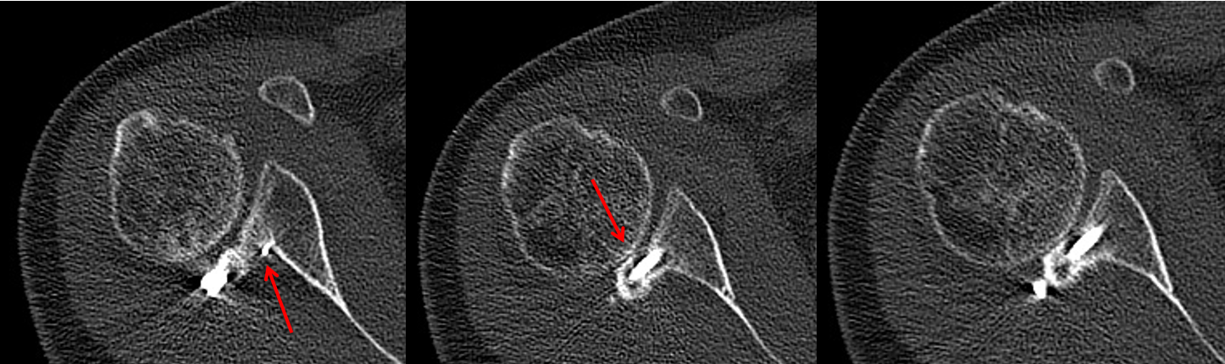

***9/5/2020***

***Tom Norris***

Bassem:

Very impressive!

Even if there were to be a recurrence or arthritic degeneration later, there will be glenoid bone stock for reconstructive options. This looks excellent.

TRN

***9/5/2020***

***JP Warner***

I have seen some spectacular failures with bone grafting including one 35 yo man who went on to a GH fusion with dramatic relief. Perhaps we are considering that poor patient selection and also poor technique conspire to bad outcomes.

JPW

***JP Warner***

***9/5/2020***

Bassem: How long after his surgery was the CT made? It would be important to see the remodeling of the graft and incorporation say after a few years. JPW

***Bassem Elhassan***

***9/5/2020***

Dear ﻿JP

We did CT at 3 and 6 months and 1 year.

The CT scan I sent was the one done at one year.

He is back in Kuwait.

My plan to obtain interval CT scan on yearly basis or every other year if there are no changes in the CT scan

B