Date (CSS Member) | Message | Attached Documents
3/13/18 (Dr. Jon Warner) | Dear Members of the Codman Shoulder Society,  Enclosed below is a link* to a recent company presentation by Stephen Burkhart regarding a multicenter study and lessons learned with superior capsular reconstruction. I recommend everyone keep an open mind and consider his message and the application of this procedure in appropriate cases.
3/13/18 (Dr. Ruth Delaney) | Thanks for sharing this. Our experience so far with SCR has been mostly positive (we are just finishing writing up our initial series of 25 cases with minimum 2 year follow up, 2 failures and 23 v good/excellent results). We have found patient selection to be of key importance (Hamada grade especially). I have no financial relationship with the company who are pushing it, but it seems to be a good option for the appropriate patients. It will be interesting to see, as we become more and more comfortable with doing RSA on slightly younger patients, where the relative indications for each will settle out.  https://www.vumedi.com/video/superior-capsular-reconstruction-using-dx-matrix/
3/13/18 (Dr. Jon Warner) | Ruth: Thanks for the follow-up. I am going to ask my RA’s to archive these comments for cases and for such notifications so we can all see where we stand and if it changes. We just finished reviewing around 50 cases at MGH with the bulk performed by one surgeon. I do not know the exact selection criteria but the reoperation rate in the first year was 35%....
3/13/18 (Dr. James Esch) | JP ... this is good discussion. Some surgeons have more problems w SCA than others. Is this patient selection or surgical skill or some other factors...
3/13/18 (Dr. Jon Warner) | Hi Jim: The purpose of this and other discussions is to stimulate interest and keep an open mind. We plan to present all comments on such topics and then revisit going forward. Most likely best format would be facebook for CSS and Joe Eichenger and Joaquin and others may work on this. Additionally, we have had very useful input on crowd-sourcing opinions for difficult cases as people seem to want to contribute to the community and help.
3/13/18 (Dr. John Macy) | Interesting. I've had some very good results over the last two yrs with about 15 SCR patients, no “failures” yet…...  Two comments/questions:  I think graft thickness is paramount. When I first started doing this with dermal allograft, all I could get was the Conexa 1-1.5mm grafts, so I doubled them over, sewed around the edge with a 2-0 Fiberwire, and got my 3mm graft. Painful (for me) but worked well. Now I use the Mitek thicker 3mm dermal grafts and just recently got the Arthrex Arthroflex thicker graft approved. Not sure why different grafts took longer to get approved, other than cost differential (which is nil). Stryker and others now have these “thicker” grafts. Wondering what others are using??  Also, I incorporate the free edge of the remaining RTC up and over the graft and sew it over the edge of the graft as much as possible (using the already placed medial anchors). I can usually cover the medial and posterior 1/3 of the graft (different than just putting few stitches in the posterior edge). Is this a good idea?? Maybe increases blood supply to graft and helps restore force couples?  I have not done this procedure if there is greater than grade 2-3 diffuse degenerative changes.  Wondering why MGH experience has 35% failure rate?? Patient selection?? Revisions?? Will be important to understand this.  And would love Larry to tell me the cost-effectiveness of this procedure...
3/13/18 (Dr. Ruth Delaney) | Over here we have only had access to the porcine dermal graft, DX Matrix, which we have to double over. The reasons we don't have human allograft/Arthroflex were initially regulatory, and then cost. Duncan Tennant from London showed me how he has been using Dermabond instead of stitching the two layers of the doubled over graft together and that has been working well (off label use of the skin glue). It will be interesting to see how the results of porcine dermal xenograft compares to human dermal allograft.  I agree about incorporating any remaining cuff medially into the reconstruction when possible - it's technically more challenging than when there is nothing there to use, but it seems to add more compression to the graft down onto the glenoid when the sutures from those glenoid anchors are passed through the cuff after graft passage. Maybe helps biologically too. Just anecdotal thoughts at this point...  I also don't do SCR if greater than grade 2 diffuse changes - I have gone in on two patients planning to do it but the joint looked worse than on imaging so I bailed and just did a debridement, suprascapular nerve release, biceps tenotomy etc. Both were in their 60s and can have a reverse if/when needed. Tougher decision in younger patients.
3/13/18 (Dr. Peter Millett) | I know there was a debate on this topic recently. Here is some data we presented at AANA comparing SCR and LDTT. I now pretty much do mostly SCR instead of LDTT.  SCR results have been very good. In about 50 cases, overall very satisfied. One revision for medial failure – re-repaired to glenoid and did well.  One revision for functional failure (inability to raise arm/still pseudoparalytic) and converted to RTSA. Graft was totally healed to both glenoid and humerus. Doing biomechanics and histology testing on the retrieved specimen now.  3 anchors on glenoid is helpful for most larger tears. Have published some biomechanics of this in AJSM. | AANA Moderator SCRvsLDT
3/15/18 (Dr. Jon Warner) | Peter: Thanks for including your excellent paper. I've taken the liberty to comment throughout the paper and point out the methodological deficiencies. This is not to be critical but to draw attention to the high purpose of a multicenter study which I think Codman Shoulder Society could do. I am sending this to all C.S.S. members as perhaps someone wants to take this on.  Keep up the good work | AANA Moderator SCRvsLDT +JPW comments
3/15/18 (Dr. Larry Higgins) | Too early to tell what the cost effectiveness will be - although delaying surgery does have a benefit in younger patients.  I saw Matthew Ravenscroft use an internal brace over the top to load share for the largest tears. Very slick...

* https://www.arthrex.com/resources/presentation/xdRArhyLRkWbugFh4zwKmg/superior-capsular-reconstruction-scr-the-new-gold-standard-for-the-irreparable-cuff-tear-in-active-patients?utm_source=WH+WNSE+AAOS&utm_medium=EMAIL&utm_content=CPV+STEPHEN+S+BURKHART+MD+SUPERIOR+CAPSULAR+RECONSTRUCTION+SCR+THE+NEW+GOLD+STANDARD+FOR+THE+IRREPARABLE+CUFF+TEAR+IN+ACTIVE+PATIENTS+CASE+PRESENTATION+VIDEO+SHOULDER&utm_campaign=WHATS+NEW+031218#share-assetvideo-modal

Arthroscopic Superior Capsule Reconstruction (SCR) vs. Latissimus Dorsi Transfer (LDT): A Comparison of Early Clinical Outcomes

Jonathan A. Godin, MD, MBA, Jonas Pogorzelski, MD, Marilee Horan, MPH, Erik Fritz, MD, Jan Christoph Katthagen, MD, Peter J. Millett, MD, MSc

Short-form/Running-title: SCR versus Latissimus Dorsi Transfer Outcomes

Research performed at the Steadman Philippon Research Institute

Affiliation for Authors:
† Steadman Philippon Research Institute, 181 West Meadow Drive Suite 1000, Vail, CO. 81657
* The Steadman Clinic, 181 West Meadow Drive Suite 400, Vail, CO. 81657

Acknowledgements: The authors would like to thank Arthrex, Inc. Naples, FL., for providing funding for this project.

Corresponding Author:
Peter J. Millett, MD, MSc
Steadman Philippon Research Institute
The Steadman Clinic, 181 West Meadow Drive, Suite 400
Vail, Colorado 81657, Telephone: 970-479-5876 , Fax: 970-479-9753
drmillett@thesteadmanclinic.com

ABSTRACT

Purpose: Arthroscopic superior capsule reconstruction (SCR) has been introduced as an alternative to latissimus dorsi transfer (LDT) for the treatment of irreparable rotator cuff tears. The purpose of this study is to compare early clinical outcomes following SCR versus those following LDT for the treatment of massive, irreparable rotator cuff tears. Our hypothesis is that preliminary clinical outcomes for SCR patients will not significantly differ from those of LDT patients.

Methods: Patients who underwent either a LDT or a SCR and were a minimum of 12 months out from surgery respectively. In the SCR technique, a 3 mm thick acellular human dermal allograft was customized to the exact size of the defect. Operative, objective, and demographic data were prospectively collected and retrospectively reviewed. Patient-reported outcome (PRO) measures included ASES, SANE, QuickDASH, SF-12 and patient satisfaction scores. Acromiohumeral distance (AHD) was measured and Hamada classification applied. Patients progressing to reverse shoulder arthroplasty (rTSA) were considered failures.

Results: Thirty-four patients (13 women, 21 men) with a mean age of 52 ± 7.4 years were included in this study. Sixteen patients underwent SCR reconstruction with a mean follow-up of 1.03 years (1- 1.6 years), while 18 patients underwent allograft augmented LDT with a mean follow-up of 5.5 years (2- 10.5 years). Compared to the SCR group, the LDT group was significantly younger (49 years vs. 56 years; p=0.006) and had a higher percentage of Workman’s Compensation cases (61% vs. 6%; p=.001) (Were the two groups similar in lag signs and degree of weakness as well as muscle atrophy? Current standard for LD transfer is arthroscopic assisted without allograft and SOS analysis shows process of recovery very similar to regular arthroscopic rotator cuff repair. Also, what about cost-effectiveness analysis though this was not part of this study). Two patients (11%) in the LDT group progressed to rTSA and were considered failures. Two additional patients (11%) in the LDT group had subsequent surgery around one-year post-operatively - one arthroscopic cuff repair and one hardware removal with debridement. In those who did not fail, pain significantly decreased post-operatively in both groups (p<0.05). Mean SF-12 PCS, ASES, and SANE scores improved significantly in the SCR group, while only the ASES pain score improved significantly in the LDT group. Mean change in abduction and flexion were -7.3° and 0.6°, respectively, in the LDT group, compared to 56.0° and 21.7°, respectively, in the SCR group. At final follow-up, patient satisfaction was a median of 8/10 in both groups. The AHD improved significantly after surgery in both groups but did not differ between groups. (Was the improvement of AHD statistically significant from preop and was measurement within standard of error in terms of mm’s?)

Conclusion: In this level 3 comparative study, SCR provided clinical results which were comparable to, and in some parameters better than (which?), LDT at early follow-up. Patients who underwent SCR had significantly improved clinical outcome scores and improved range of motion compared to patients who underwent LDT. Better study designs and longer follow-up are needed to investigate these observations further. (Did you use process of recovery measurement per SOS to determine difference in speed and experience of recovery?)

INTRODUCTION
In an aging and increasingly active population, irreparable rotator cuff tears (RCTs) present a particularly complex and difficult challenge. The prevalence of full-thickness RCTs in the general population is approximately 20% and increases with patient age^{1,2}. About 17% to 36% of all RCTs can be classified as massive tears³⁻⁵ using Cofield’s definition of a diameter of five centimeters or greater⁶. Tissue inelasticity, poor tendon quality, adhesions, muscle atrophy, and fatty infiltration can all contribute to irreparability. Many treatment options exist for massive, irreparable tears, including debridement, partial rotator cuff repair⁷, patch-augmented rotator cuff repair⁸, bridging rotator cuff reconstruction with a graft⁹, latissimus dorsi tendon transfer¹⁰ (LDT), and arthroscopic superior capsule reconstruction¹¹ (SCR).

Both LDT and SCR are acceptable treatment options for patients with massive, irreparable RCTs without signs of rotator cuff arthropathy. LDT was introduced in 1988 by Gerber et al.¹⁰ and acts as a humeral head depressor and active external rotator. However, some authors have expressed concerns regarding LDT, including the lack of active, coordinated, synchronous contraction with arm elevation.^{12,13} In general, LDT has shown acceptable long-term results,¹⁴ even though it does not restore normal anatomy or function. A systematic review of ten studies by Namdari et al.¹⁵ found improvement in shoulder function, range of motion, strength, and pain relief after LDT, but the authors cautioned that patients and physicians should not expect "normal" function or complete pain relief following this procedure.

SCR was first reported by Mihata et al.¹⁶ in a 2012 cadaveric biomechanical study as an effective means of restoring superior humeral head translation. Shortly thereafter, early clinical results demonstrated significantly improved pain levels and clinical outcomes scores at two years post-operatively in 23 patients who underwent SCR with a fascia lata autograft¹⁷. Both LDT and SCR therefore are reasonable options for the treatment of massive irreparable RCT’s. The LDT has the advantage of being a functional muscle transfer but has the disadvantage of being maximally invasive and altering normal anatomy. The SCR has the advantage of being minimally invasive and restoring the superior capsule of the shoulder but has the disadvantage of being only a static stabilizer. Whether these differences translate into differences in clinical outcome remains unknown. Furthermore, to our knowledge, LDT and SCR outcomes have not been directly compared. Therefore, the purpose of this study is to compare early clinical outcomes following SCR versus those following LDT for the treatment of massive, irreparable rotator cuff tears. Our hypothesis is that preliminary clinical outcomes for SCR patients will not significantly differ from those of LDT patients.

METHODS
This study was approved by the Institutional Review Board at our institution. Surgical, objective, and demographic data were prospectively collected and retrospectively reviewed. All patients undergoing SCR or LDT by the senior surgeon who were a minimum of 12 months following surgery were eligible for study inclusion. Exclusion criteria included patients with previous ipsilateral glenohumeral joint reconstructions or previous infection of the index shoulder. (Non-randomized,right? Any concern for bias of selection?). Comparable groups in terms of FA and lag signs?)

Surgical techniques
All surgery was performed by the senior surgeon with the patient under general anesthesia in the beach chair position. The patients in this study were not randomized. Rather, the senior surgeon switched from exclusively using LDT to exclusively using SCR for massive, irreparable rotator cuff tears without associated glenohumeral arthritis during the course of the study.

The LDT technique employs an open or arthroscopically assisted approach in the beach chair position¹⁸. The rotator cuff tear is first examined arthroscopically to assess the feasibility of repair. If the tear is deemed irreparable, a deltoid split is performed to access and the greater tuberosity and a second incision is made along the posterior aspect of the shoulder, which permits access to and full mobilization of the latissimus dorsi muscle. If the tendon appeared to be too short to reach the footprint, an Achilles tendon allograft was sutured into the tendon stump to reduce tension of the muscle/tendon unit and subsequently transferred to the superior aspect of the humerus to exert a downward and externally rotating force at the glenohumeral joint ¹⁸. (Neither Gerber or I ever used an tendon extension method for LD transfer and certainly this is not necessary with arthroscopic techniques. See my video on vumedi) The allograft or tendon is subsequently fixed to the bone with multiple suture anchors¹⁹.

The complete operative technique utilized for SCR has been previously described by Petri et al.²⁰ using a 3 mm thick acellular human dermal allograft that is fixed to the glenoid medially and the greater tuberosity laterally.

Of note, an acromioplasty was performed in all cases of LDT and SCR.

Rehabilitation for each procedure consists of immediate post-operative immobilization followed by passive range of motion initiated at six weeks, active range of motion permitted between six and eight weeks, and strengthening commencing after eight weeks. SCR patients obtain x-ray to assess humeral head position between two and three months postoperatively. (Any tendon transfer training methods such as biofeedback? See my Vumedi video of such a case)

Outcome measures
Patients reported outcomes (PROs) were collected pre-operatively, 12 months post-operatively, 24 months post-operatively, and yearly thereafter. The questionnaire included the American Shoulder and Elbow Surgeons (ASES) score, Quick Disabilities of the Arm, Shoulder and Hand (QuickDASH) score, the Single Assessment Numeric Evaluation (SANE), and the Short-Form 12 Physical Component Summary (SF-12 PCS). Patient satisfaction with outcome was rated on a ten-point scale, with one being highly unsatisfied and ten being highly satisfied. Pre- and post-operative outcomes scores were compared for both groups. The acromiohumeral distance (AHD) was measured pre-and postoperatively by an orthopedic surgeon (method of measurement and accuracy of xray projection? Multiple measures for intra-oberver variability? Degree of measurement difference deemed to be accurate?). Clinical failures were defined as patients progressing to RTSA. Failure not defined by pain and dysfunction even if they did not yet progress to revision surgery? This is only a one year study and things could change in year 2?). Patients that progressed to arthroplasty were excluded from the PRO comparison statistical analysis, as the outcomes represented those of the arthroplasty.

Statistical analysis
A post hoc power analysis was not appropriate due to the retrospective nature of this study. Pre- versus post-operative outcomes scores were compared within treatment groups using the Wilcoxon signed-rank test. Post-operative outcomes scores were compared between treatment groups using the Mann-Whitney U test. Surgical time and age were compared between groups with unpaired Student t-test. Bivariates were compared using chi-square analysis. For imaging, inter-rater reliability was evaluated using intra-class correlation coefficient.

RESULTS
Thirty-six patients (14 women, 22 men) with a mean age of 52 ± 7.4 years were included in this study. Sixteen patients underwent SCR reconstruction, while twenty patients underwent LDT (Figure 1). Two patients in the LDT group refused to complete the PRO questionnaire and were removed from the data analysis. Compared to the SCR group, the LDT group was significantly younger (49 years vs. 56 years; p=0.004) and had a higher percentage of Workman’s Compensation cases (65% vs. 6.2%; p<0.001) (Does WC affect validity of conclusions since this population is always worse than Non-WC?). Failure occurred in two (11%) patients in the LDT group, both of whom progressed to rTSA. Two additional patients (11%) in the LDT group had subsequent surgery around one-year postoperatively (Probably groups were too small for valid comparison. A multicenter study with randomization would be best. Perhaps Codman Shoulder Society could help with this). One was an arthroscopic rotator cuff repair and another one underwent hardware removal and debridement. In patients who did not experience failure, pain significantly decreased post-operatively in both groups (p<0.05)(Tables 1 & 2). Figure 3 depicts the different ASES score trajectories.
Figure 1: Study flow diagram
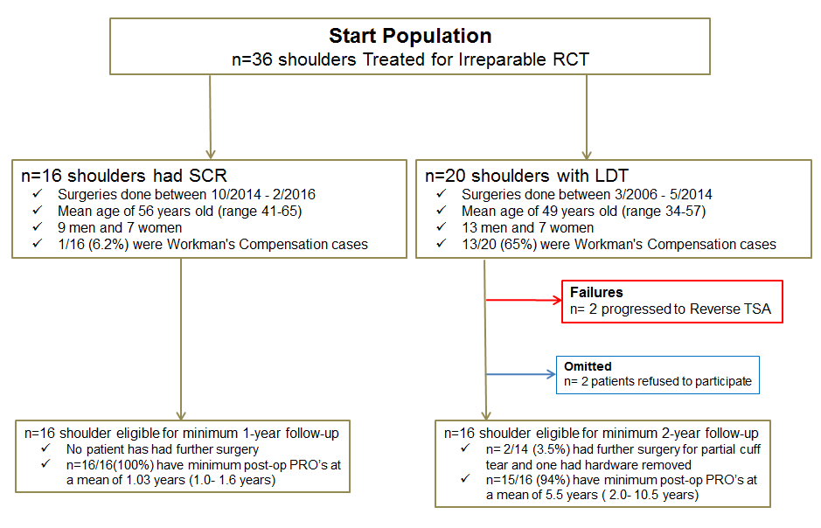

Table 1. SCR PROs
 | Pre-op  Mean -59.5 days (range -181 to -1) | Post-op  Mean 1.03 years (range 1-1.6) | P-value
SF -12 PCS | 38.8+4.2 | 47.6+7.7 | .011*
SF 12 MCS | 50.3 +11.6 | 55.1+11.4 | .510
ASES score | 57.5+16.0 | 82.2+ 10.7 | .012*
ASES pain | 32.3 +12.3 | 45.6 +5.7 | .004*
ASES function | 24.8 +8.3 | 36.8 +7.6 | .004*
QuickDASH | 38.9+ 17.2 | 20.7+ 16.3 | .055
SANE | 46.2+ 28.1 | 70.9+ 16.1 | .019*
Satisfaction |  | 8/10 (range, 5-10)

Table 2. LDT PROs
 | Pre-op  Mean -48 days  (range -260 to -18) | Post-op  Mean 5.5 years  (range 2-10.5) | P-value
SF -12 PCS | 36.9+5.8 | 45.3 +9.8 | .091
SF 12 MCS | 44.0 +14.6 | 48.7 +12.2 | .477
ASES score | 52.0 +17.2 | 63.3 +28.0 | .154
ASES pain | 32.1 +12.5 | 34.7 + 16.0 | .024*
ASES function | 18.8+ 9.8 | 28.6 +14.1 | .109
QuickDASH | 48.4+ 22.0 | 35.7+26.5 | .110
SANE | 39.6+ 16.0 | 54.1+ 23.2 | .173
Satisfaction |  | 8/10 (range 1-10)

At final follow-up, satisfaction was a median 8/10 points in both groups, but not significantly different between the two groups (p=0.052). Abduction decreased from 112° pre-operatively to 99° one year post-operatively for the LDT group and increased from 100° pre-operatively to 130° six months after the surgery for the SCR group. In addition, flexion increased from 117° pre-operatively to 118° post-operatively for the LDT group and from 135° pre-operatively to 158° post-operatively for the SCR group. Mean change in abduction and flexion were -7.3° and 0.6°, respectively, in the LDT group, compared to 56.0° and 21.7°, respectively, in the SCR group. The mean post-operative AHD in the LDT grou p was 7.94 ± 2.4 mm compared to 8.66 ± 1.7 mm in the SCR group (p=0.367), but both groups showed a significant change in AHD following surgery (Table 3). There was no significant correlation between post-operative AHD and outcomes scores (Table 4).
Table 3. AHD Outcomes (Most did not have significant superior displacement?)
 | Pre-op AHD | Post-op AHD | P-value
SCR | 6.23 ± 2.3mm | 8.66 ± 1.7mm | .003*
LDT | 7.04 ± 1.8mm | 7.94 ± 2.4mm | .007*

Table 4. Correlations between post-operative AHD and outcomes scores
 | LDT  rho | P value | SCR  rho | P-value
SF -12 PCS | -0.046 | 0.826 | 0.015 | 0.958
ASES score | 0.058 | 0.776 | 0.109 | 0.710
QuickDASH | -0.137 | 0.504 | -0.053 | 0.857
SANE | 0.200 | 0.339 | -0.003 | 0.991

Figure 3. ASES Total Scores Over Time (Which way will the red line move in next year or two?)
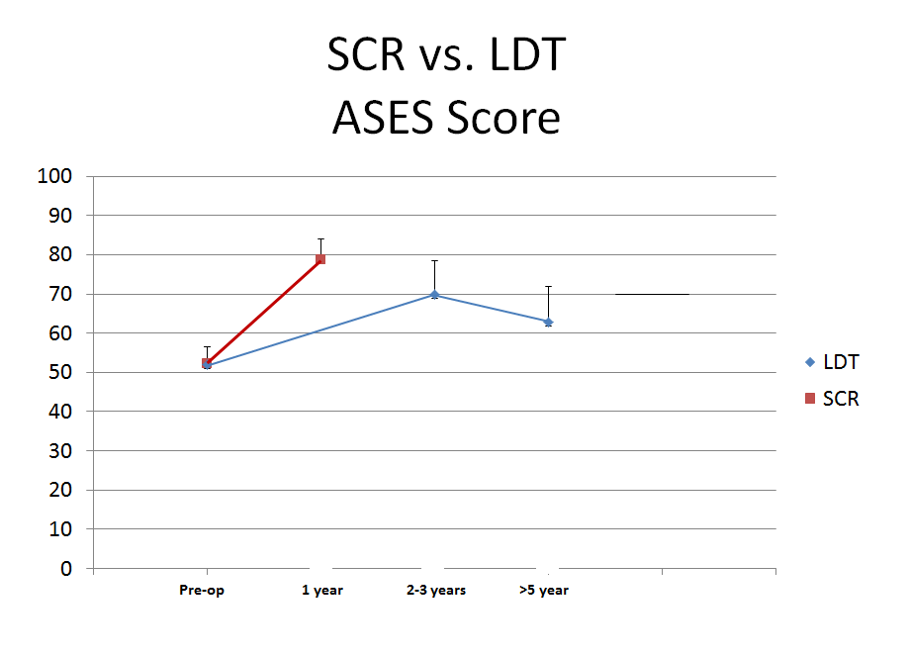

DISCUSSION
The most important finding of this study is that the short-term PROs for patients undergoing SCR seem to be superior in the short term follow up comparable to LDT. Furthermore, the longer term follow-up in the LDT group shows that PROs steadily decline over time (Groups very small and we don’t know what will happen with SCR next year?). At final follow-up, both treatment groups demonstrated significant improvement in ASES pain scores; however, only the SCR group showed significant improvement in ASES function, SF-12 PCS and SANE scores. Moreover, the SCR group demonstrated a greater improvement, albeit without statistical significance, in flexion and abduction compared to the LDT group.
Mihata et al.¹⁷ reported the outcomes of 23 patients with minimum 2-year follow-up after SCR. They demonstrated an improvement in average ASES score from 23.5 ± 14.4 pre-operatively to 92.9 ± 11.3 post-operatively. Meanwhile, the average AHD increased from 4.6 mm ± 2.2 pre-operatively to 8.7 mm ± 2.6 post-operatively, while the average active elevation increased from 84° ± 52.2 pre-operatively to 148° ± 33.4 post-operatively¹⁷. These results are similar to our findings, though notable differences in methodology include the use of fascia lata autograft by Mihata et al. and minimum follow-up period.¹⁷
A recent biomechanical study advocates for the incorporation of the SCR graft to the residual native infraspinatus as a means to restore superior stability of the glenohumeral joint²¹. The same group showed that superior stability of the shoulder joint was restored when the graft was attached at 10° or 30° of glenohumeral abduction²¹. In addition, this study noted that a thicker fascia lata graft (8 mm) provided greater stability than a thinner graft (4 mm).²² Finally, this study group showed that the addition of a concomitant acromioplasty, as was done in our surgical technique, decreased the subacromial contact area without increasing the subacromial contact pressure²³. Similar cadaveric biomechanical studies have been conducted to assess LDT. Oh et al.²⁴ demonstrated that LDT restores glenohumeral rotation and kinematics at 0° of abduction, but may lead to increased glenohumeral contact pressure at higher abduction angles. Likewise, Omid et al.²⁵ reported that lower trapezius transfer is superior to latissimus transfer at restoring native glenohumeral kinematics and joint reaction forces.
While literature on allograft-augmented LDT is limited to case reports¹⁰, multiple studies reported results after traditional LDT. El-Azab et al.¹⁴ published clinical results of 115 shoulders with the longest follow-up period following LDT with a mean follow-up of 9.3 years. Compared to our results, El-Azab et al. achieved similar ASES scores (30 ± 13 pre-operatively to 70 ± 17 post-operatively). However, they did note a much greater improvement in both average flexion (86° ± 30° to 134° ± 36°) and average abduction (89° ± 41° to 127° ± 37°) than we saw in our cohort¹⁴. This could potentially be attributed to their longer follow-up period with a mean of 9.3 years compared to our mean follow-up of 5.5 years or it can be due to the different techniques used. Of note, the average AHD in their study decreased from 5.9 mm ± 2.4 mm pre-operatively to 4.9 mm ± 2.3 mm post-operatively, while the average AHD in our cohort increased by nearly one millimeter.¹⁴ Birmingham et al.²⁶ reported outcomes of 18 patients following LDT and noted similar mean post-operative ASES scores (61) and flexion (137°) to those in our study.
There are several limitations to this study. Due to the study’s retrospective nature, some of the PROs are incomplete. Also, due the unique nature of this surgery, there was no way to increase the statistical power by adding more patients; therefore, we are at risk of a type II error. Moreover, the patients in this study were not randomized. Rather, the senior surgeon switched from almost exclusively using LDT to exclusively using SCR during the course of the study. As a result, selection bias due to non-randomization is possible and, consequently, the SCR group has a significant shorter follow-up length than the LDT group limiting the comparability of the results at final follow-up. Nevertheless, the improved early results with SCR certainly suggest that the technique has merit and warrants further study. (This is worth a prospective, randomized study using contemporary methods of LD or LTT arthroscopic techniques vs SCR)

CONCLUSION
In this level 3 comparative study, SCR provided clinical results which were comparable to, and in some parameters better than, LDT at early follow-up. Patients who underwent SCR had significantly improved clinical outcome scores and improved range of motion compared to patients who underwent LDT. Better study designs and longer follow-up are needed to investigate these observations further.

REFERENCES
1. Minagawa H, Yamamoto N, Abe H, Fukuda M, Seki N, Kikuchi K, Kijima H, Itoi E. Prevalence of symptomatic and asymptomatic rotator cuff tears in the general population: From mass-screening in one village. J Orthop. 2013 Feb 26;10(1):8-12.
2. Yamamoto A, Takagishi K, Osawa T, Yanagawa T, Nakajima D, Shitara H, Kobayashi T. Prevalence and risk factors of a rotator cuff tear in the general population. Journal of Shoulder and Elbow Surgery. 2010;19:116-120.
3. Ellman H, Hanker G, Bayer M. Repair of the rotator cuff. End-result study of factors influencing reconstruction. J Bone Joint Surg Am. 1986 Oct;68(8):1136-44.
4. Harryman DT, 2nd, Mack LA, Wang KY, Jackins SE, Richardson ML, Matsen FA, 3rd. Repairs of the rotator cuff. Correlation of functional results with integrity of the cuff. J Bone Joint Surg Am. 1991 Aug;73(7):982-9.
5. Warner JJ. Management of massive irreparable rotator cuff tears: the role of tendon transfer. Instr Course Lect. 2001;50:63-71. Review.
6. Cofield RH. Rotator cuff disease of the shoulder. J Bone Joint Surg Am. 1985 Jul;67(6):974-9.
7. Kim SJ, Kim SH, Lee SK, Seo JW, Chun YM. Arthroscopic repair of massive contracted rotator cuff tears: aggressive release with anterior and posterior interval slides do not improve cuff healing and integrity. J Bone Joint Surg Am. 2013 Aug 21;95(16):1482-8.
8. Petri M, Warth RJ, Horan MP, Greenspoon JA, Millett PJ. Outcomes After Open Revision Repair of Massive Rotator Cuff Tears With Biologic Patch. Arthroscopy. 2016 Sep;32(9):1752-60.
9. Gupta AK, Hug K, Boggess B, Gavigan M, Toth AP. Massive or 2-tendon rotator cuff tears in active patients with minimal glenohumeral arthritis: clinical and radiographic outcomes of reconstruction using dermal tissue matrix xenograft. Am J Sports Med. 2013 Apr;41(4):872-9.
10. Skedros JG, Henrie TR. Latissimus Dorsi Tendon Transfer with GraftJacket(R) Augmentation to Increase Tendon Length for an Irreparable Rotator Cuff Tear. Case Rep Orthop. 2017;2017:8086065.
11. Mihata T, Lee TQ, Watanabe C, Fukunishi K, Ohue M, Tsujimura T, Kinoshita M. Clinical results of arthroscopic superior capsule reconstruction for irreparable rotator cuff tears. Arthroscopy. 2013 Mar;29(3):459-70.
12. Iannotti JP, Hennigan S, Herzog R, et al. Latissimus dorsi tendon transfer for irreparable posterosuperior rotator cuff tears. Factors affecting outcome. The Journal of bone and joint surgery. American volume. 2006;88:342-348.
13. Zafra M, Carpintero P, Carrasco C. Latissimus dorsi transfer for the treatment of massive tears of the rotator cuff. International orthopaedics. 2009;33:457-462.
14. El-Azab HM, Rott O, Irlenbusch U. Long-term follow-up after latissimus dorsi transfer for irreparable posterosuperior rotator cuff tears. J Bone Joint Surg Am. 2015 Mar 18;97(6):462-9.
15. Namdari S, Voleti P, Baldwin K, Glaser D, Huffman GR. Latissimus dorsi tendon transfer for irreparable rotator cuff tears: a systematic review. J Bone Joint Surg Am. 2012 May 16;94(10):891-8.
16. Mihata T, McGarry MH, Pirolo JM, Kinoshita M, Lee TQ. Superior capsule reconstruction to restore superior stability in irreparable rotator cuff tears: a biomechanical cadaveric study. Am J Sports Med. 2012;40:2248-55.
17. Mihata T, Lee TQ, Watanabe C, Fukunishi K, Ohue M, Tsujimura T, Kinoshita M. Clinical results of arthroscopic superior capsule reconstruction for irreparable rotator cuff tears. Arthroscopy. 2013 Mar;29(3):459-70.
18. Gaskill TR, Millett PJ. Latissimus Dorsi Transfer in the Modified Beach Chair Position. Posted on VuMedi 2015. (https://www.vumedi.com/video/latissimus-dorsi-transfer-in-the-modified-beach-chair-position/) Acquired link 4/7/2017
19. Millett PJ, Gaskill TR. Latissimus dorsi tendon transfer for treatment of irreparable posterosuperior rotator cuff tears. American Academy of Orthopaedic Surgeons 2014. New Orleans, LA March 12-16, 2014
20. Petri M, Greenspoon JA, Millett PJ. Arthroscopic Superior Capsule Reconstruction for Irreparable Rotator Cuff Tears. Arthroscopy techniques. 2015;4:e751-755.
21. Mihata T, McGarry MH, Kahn T, Goldberg I, Neo M, Lee TQ. Biomechanical Role of Capsular Continuity in Superior Capsule Reconstruction for Irreparable Tears of the Supraspinatus Tendon. Am J Sports Med. 2016;44:1423-30.
22. Mihata T, McGarry MH, Kahn T, Goldberg I, Neo M, Lee TQ. Biomechanical Effect of Thickness and Tension of Fascia Lata Graft on Glenohumeral Stability for Superior Capsule Reconstruction in Irreparable Supraspinatus Tears. Arthroscopy. 2016;32:418-26.
23. Mihata T, McGarry MH, Kahn T, Goldberg I, Neo M, Lee TQ. Biomechanical Effects of Acromioplasty on Superior Capsule Reconstruction for Irreparable Supraspinatus Tendon Tears. Am J Sports Med. 2016;44:191-7.
24. Oh JH, Tilan J, Chen YJ, Chung KC, McGarry MH, Lee TQ. Biomechanical effect of latissimus dorsi tendon transfer for irreparable massive cuff tear. J Shoulder Elbow Surg. 2013;22:150-7.
25. Omid R, Heckmann N, Wang L, McGarry MH, Vangsness CT Jr, Lee TQ. Biomechanical comparison between the trapezius transfer and latissimus transfer for irreparable posterosuperior rotator cuff tears. J Shoulder Elbow Surg. 2015;24:1635-43.
26. Birmingham PM, Neviaser RJ. Outcome of latissimus dorsi transfer as a salvage procedure for failed rotator cuff repair with loss of elevation. J Shoulder Elbow Surg. 2008;17:871-4.

