Ask yourself: How am I a resource to my hospital system and how might I create value for my institution and myself as well.

Here is some Data that may, or may not, surprise you.

If you are a physician who has worked hard to differentiate yourself by becoming an expert, and you are frustrated by an ever growing sense of being fungible or commoditized in the large institution where you work, perhaps this data will help explain your sense of frustration.

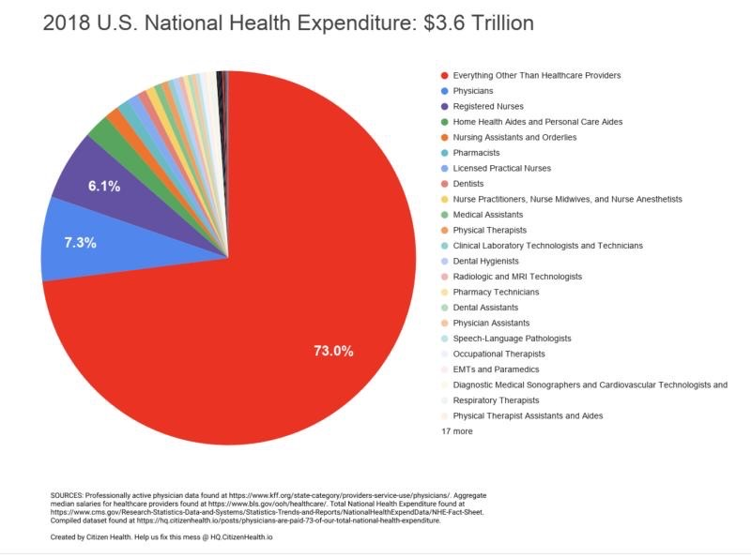
We physicians, including surgeons, are responsible for only 7.3% (Blue portion of the pie) of the entire cost of the US Healthcare system. Administrators and cost of running the entire system, what is called SG&A in the income statement, is included in the 73% (Red portion of the pie) of the remaining costs. Moreover, we determine the cost of many additional services such as radiology, physical therapy, etc. For our enormous leverage on overall cost and relatively little impact ourselves on the actual cost of care we provide, we receive little recognition and reward. This may not, of course, be the case for the minority who own their own ASC and have a collaborative relationship with their hospital. The regulatory environment in each state may differ and inclusive of the Stark laws, we may be hindered to control our own destiny and our reward for delivering value-based care. In this situation, co-management and gainsharing are a safe haven vehicle to deliver value to the institutions where we work and also become more of a valued partner. When I analyzed the income statement of our ASC I found that the variation in cost of goods and supplies (COGs) among eight surgeons performing ACL surgery was 175%. The same goes for the eight surgeons doing rotator cuff repair. While you might think this reflects a variable level of complexity, I am pretty sure that is not the case.

Here’s why we have so little leverage in large AMC’s and large Not-for-Profit enterprises such as Kaiser:

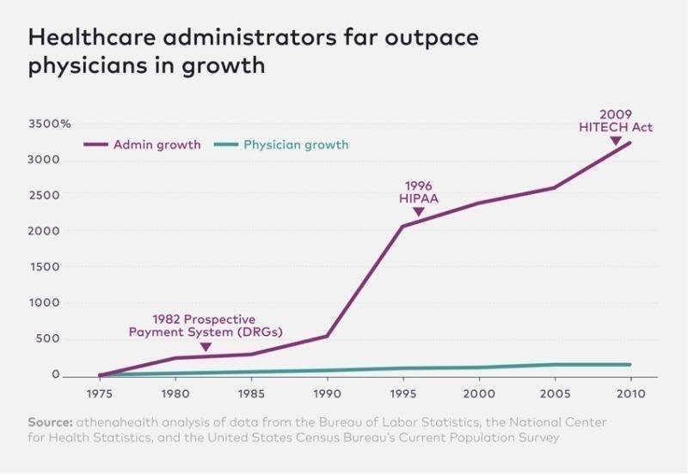

The administrative machine which overseas our multi-billion-dollar centers is growing exponentially faster than us. This is largely driven by a regulatory environment that requires more and more administrative oversight, but also by an unprecedented growth of mergers and acquisitions in healthcare. In this setting we play on a court and with a ball owned by the institution. Our only chance to be a valued player in such a setting is to provide an analysis as I’ve indicated above. If we show we can impact the bottom line (Net Profit) by impacting the income statement in terms of COGs, we position ourselves to be collaborators and partners. As downward pressure on healthcare will continue no matter who is in the White House, I strongly recommend you consider measuring your value to your organization and making such arguments.

In future postings I’ll share some insights I’ve gained from my analysis of my own institution’s financial performance in Orthopedics and place this in the context of the overall enterprise. Perhaps this will be helpful for all of you.

Best Regards,

“JP” Warner, MD
Chief, The MGH Shoulder Service
Acting Chief, The MGH Sports Medicine Service
Chair for Quality and Safety for MGH Orthopedics
Professor of Orthopedic Surgery
Harvard Medical School
Founder, The Codman Shoulder Society
Founder, The Boston Shoulder Institute
Founder, The New England Shoulder and Elbow Society

