Symptomatic Clavicular Insufficiency After Multiple Failed Surgeries: Case Discussion

8/31/2020
JP Warner
Dear CSS:

I am reaching out to you for advice on this complex case. Please review and let me know what you think. I will post this to both the Blog and the WhatsApp group. We will note all input and then post in the case section and I'll let all know what the patient decides and what we ultimately do.

Regards,

JP Warner, MD
Founder, CSS

9/1/2020
Matt Provencher

JP,

Thanks for sending along this case of distal clavicle insufficiency.

I treated my first one of these with ICBG autograft and plating and a “dovetail” integration into the end of the clavicle in about 2006.
Since then have performed about 7 of these – mostly in the range of 2.5-5.0 cm of distal clavicle insufficiency (bilateral CT scan to measure as you have done here), utilizing ICBG auto, plating, and also AC and CC ligament recon with allograft.
This has worked quite well, esp for the horizontal instability which I have found causes significant pain and issue with the posterior aspect of the clavicle abutting the scapular spine and musculature.

In addition – this has helped a lot with the significant scapular issues which are very difficult to solve, in my opinion, without having the “strut” of the clavicle present to maintain length.
Thus, the ST fusion may be also a very reasonable option – but I have reserved doing this for those that may fail (I have one) the distal clavicle augment.
Even had a couple WC patients (see that this one here in the PPT is WC) in my small series - and they have actually improved dramatically.

I have attached a published technique article for review/commentary.
Thanks,
Matt

9/1/2020
Seth Gamradt
Matt, great technique. I texted JP that not 15 minutes after his case was posted on Codman this patient walked in my clinic; clavicle is subluxated posteriorly. Any hope for conservative Rx? Seth Gamradt MD USC

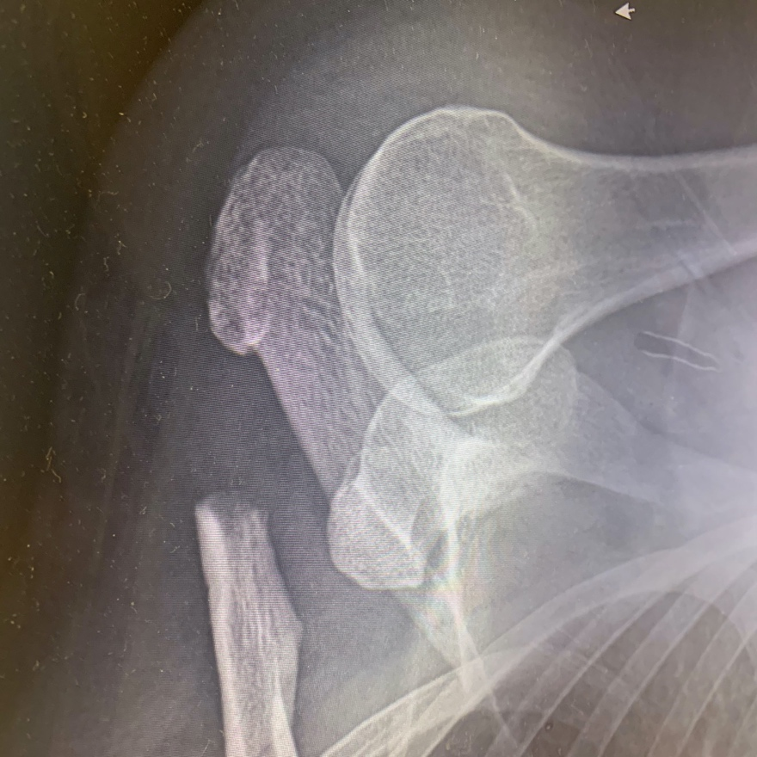

9/2/2020
Gregory Mallo

For what it’s worth- I have addressed 3 cases with horizontal micro-instability (pain with AC drawer test) and aggressive prior DCE. Normal CC distance as follows:

I Elevated large thick anterior and posterior flaps of clavipectoral fascia and tightened/ imbricated with a “pants over vest” technique. I have used a small Peek anchor (hand type anchor in lateral clavicle) to suck the fascia down the the bone and stabilize.
Sling for 2-3 weeks to allow tissue to tighten the rehab like DCE.

9/2/2020
Randy Cohn

I did a case like this while at MGH with Dr. Provencher. We used a 2cm block of iliac crest, that was added to the distal clavicle using the arthrex distal clavicle locking plate. Dogbone buttons were placed through the plate and coracoid. And a soft tissue allograft around the coracoid and clavicle.
I did ask him about why the technique had not been written up and if you had any outcomes on his series of these patients but he did not at that time. I haven’t done anything similar since being out in practice.
Hope all is well.
Randy
(If it would help I can try to find the patient’s name in my notes from fellowship to see the images)

9/2/2020
Bassem Elhassan
Dear JP
Tough problem but because it involved the lateral clavicle I do agree with what Matt has proposed with bone grafting.
However we haven’t used iliac crest for this one.
We have used instead lateral clavicle allograft or first rib autograft (it is easier to harvest it because it is in the field of exposure) ORIF of bone, ligament reconstruction and we do add Temporary pinning of the New AC until bone is confirmed to be healed by CT scan then the pins are taken out.
Of note if we used allograft for reconstruction we attach the tip of Coracoid with the Conjoint tendon left attached to it to the undersurface of the allograft as a dynamic stabilizer.
Sincerely
B

JP Warner
9/3/2020
Bassem: Thank you.

Can you give us numbers for cases you've done with this technique and can you share a case with us from standpoint of technique, radiographs and outcome? Finally, perhaps you can differentiate this from medial clavicular insufficiency which, as you know, we sometimes see after SC joint resections.

Thanks

JPW

Bassem Elhassan
9/3/2020

The number is small: 3 for allograft with coracoid tip and 2 for the rib autograft As for the medial SC joint insufficiency, completely different scenario as you have mentioned.
We have designed reconstruction by transferring and fixing the medial deficient clavicle end to end to the lateral first rib (osteotomized) and essentially creating a new SC joint distal to the original one. I mean, the costochondral joint becomes the new SC joint.
I will share techniques of both but the document might be too large to send Cheers B

9/3/2020
Ashish Bedi
Thanks JP. Very interesting case. I have treated a 50 yr old professional photographer who came to me after 5 shoulder ops after a lat clavicle fracture and acj dislocation. Active elevation 40 ER 0 VAS8. Pics below. Large segment of bone was excised. I overlayed both clavicle CtScans and evaluated 4 cm defect. Reconstrcted this with ICBG and Did a simultaneous ACJ stabilization.
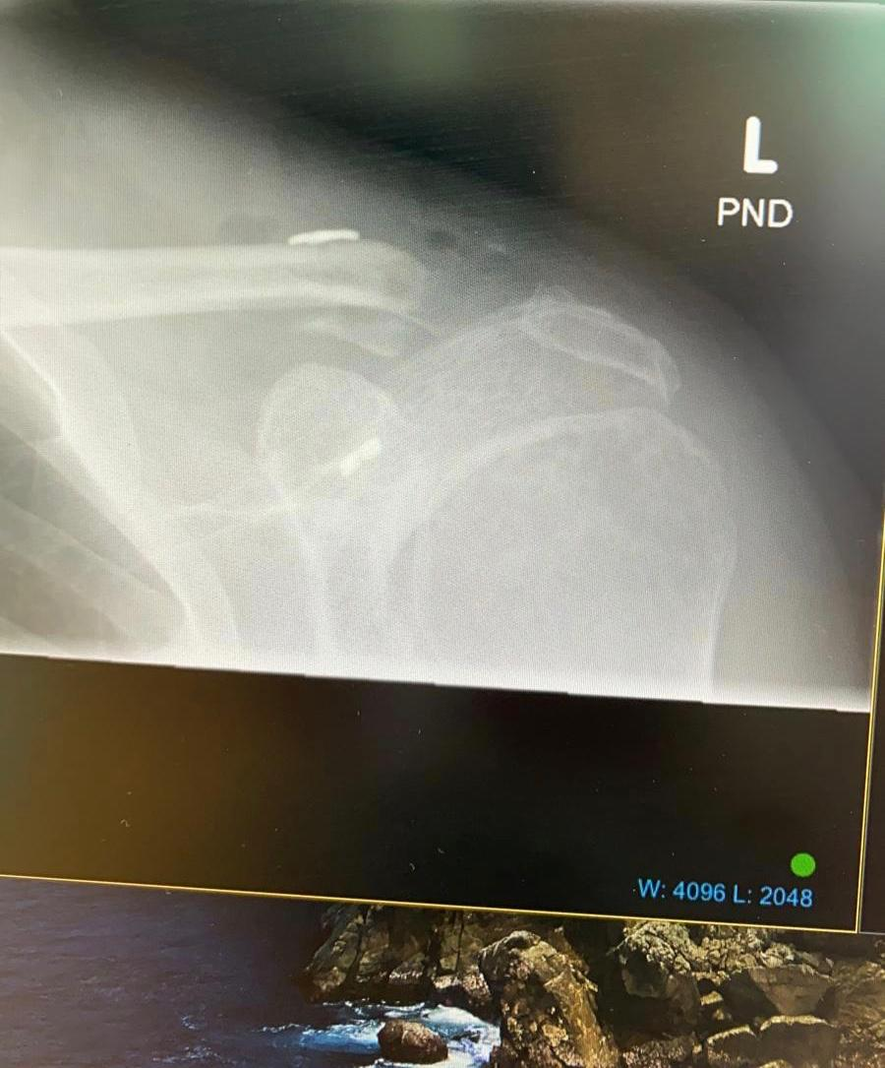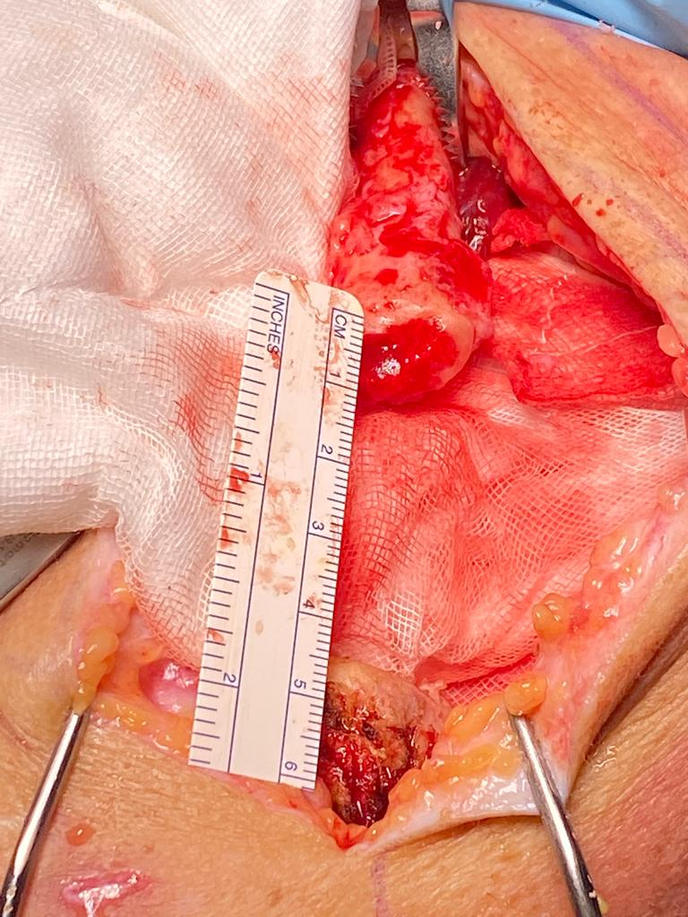
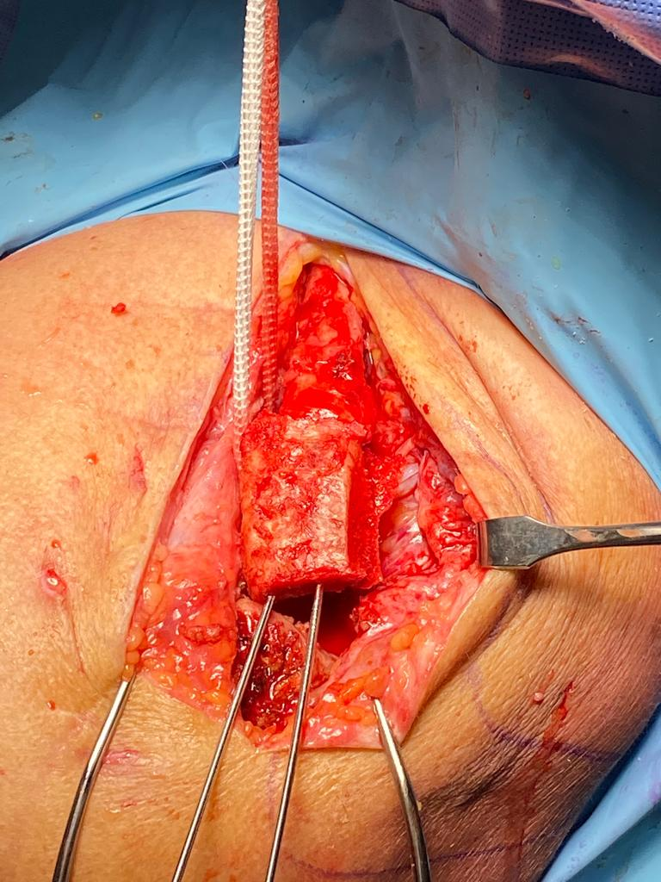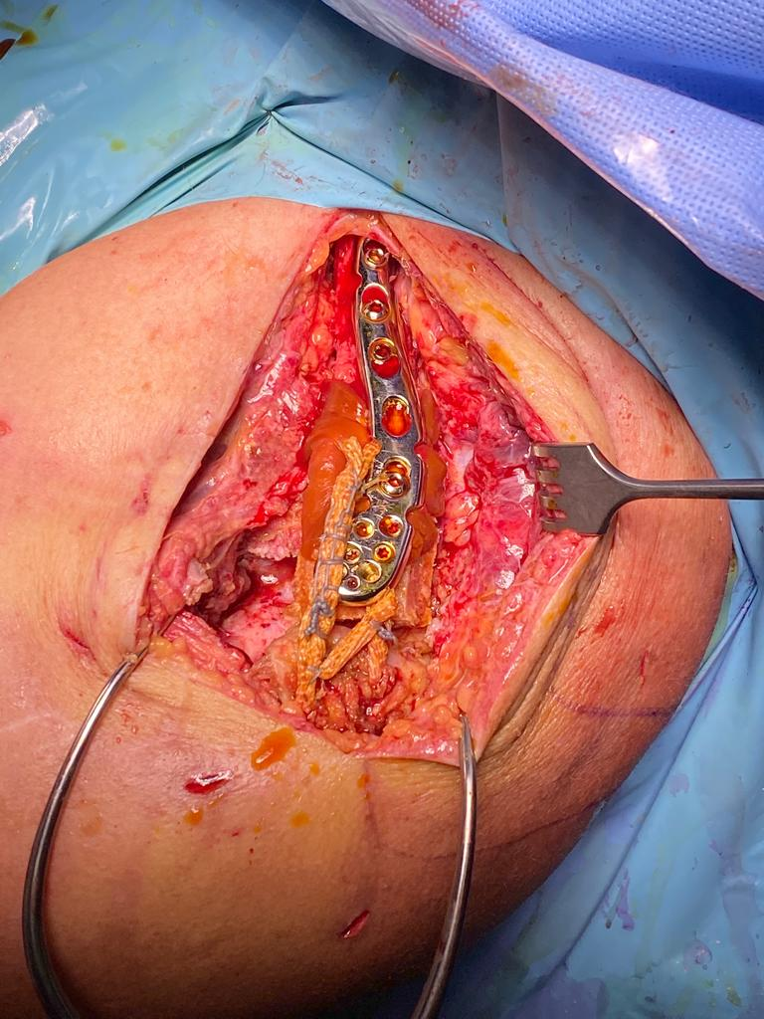
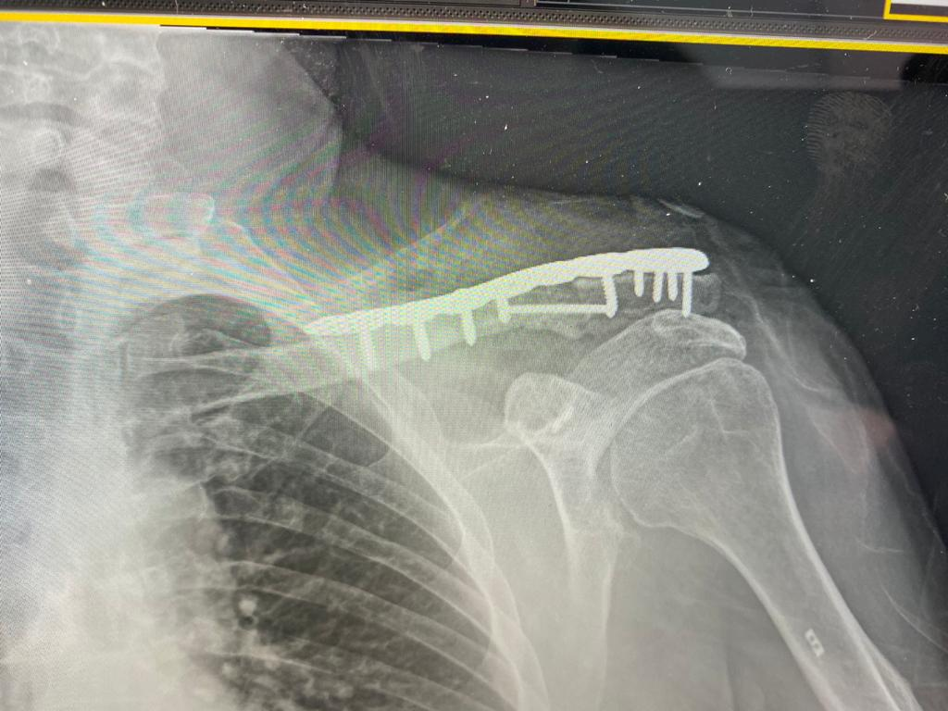
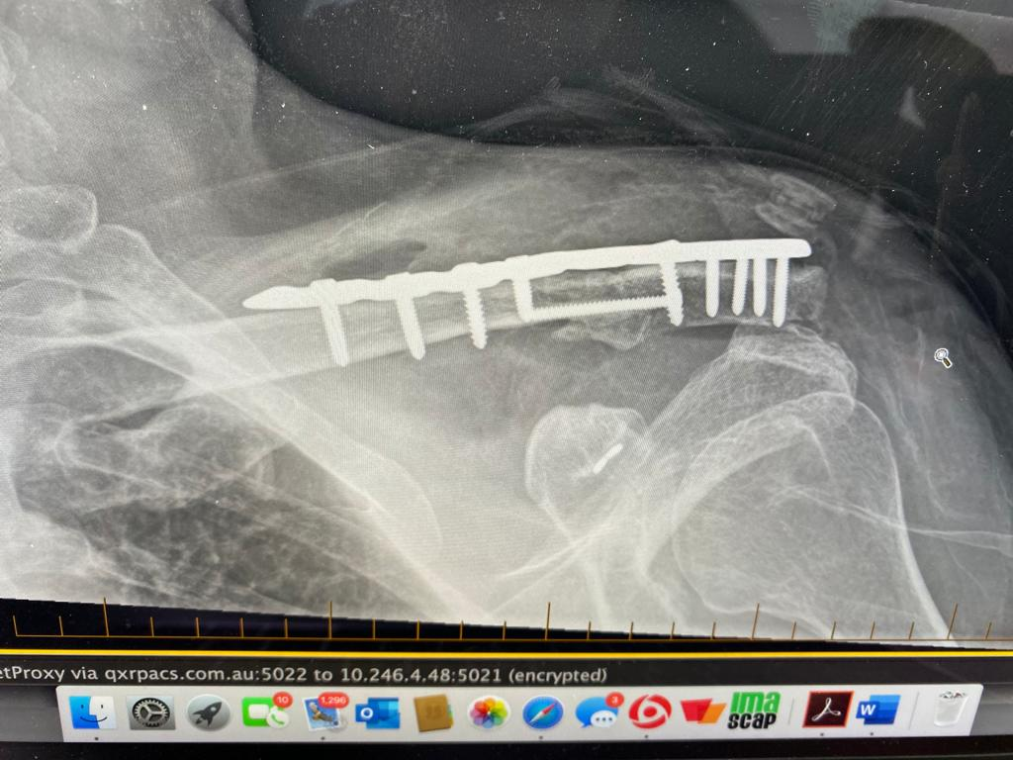
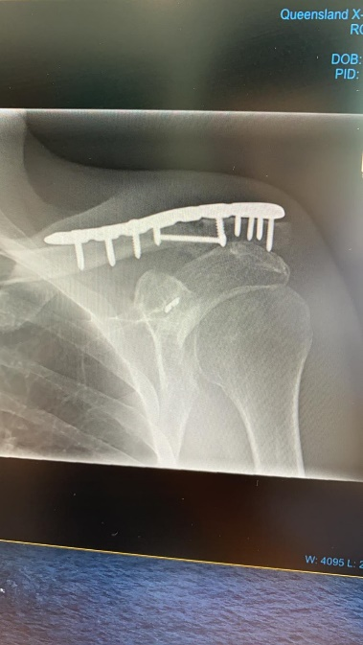

1 year post op. Was stiff at 3 months as I kept him in a sling for 8 weeks. Needed an arthrolysis. Now VAS1 elevation 140 ER 50 degrees Significant improvement in ASES Constant and SACs. He is back working. Elevation is not perfect but after 7 ops in total he’s happy.

JP Warner
9/3/2020
Ashish: Thank you for sharing this. It is especially helpful that you sent an outcome. Bassem and Matt have shared similar techniques and hopefully will send examples. For all who missed it, Matt sent an article he did on the technique. I will post all these comments and cases to the CSS website under Cases and sub-section Shoulder Girdle, and will post in the future with details of my own case.

